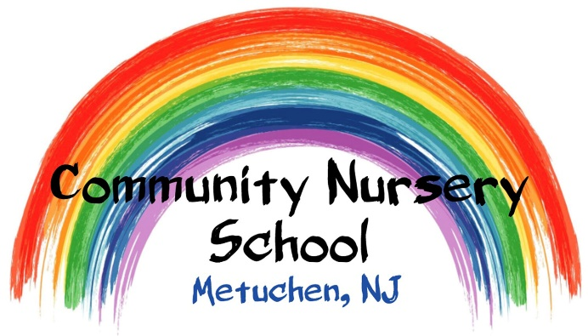

Zelle Payment Information
1. Sign into Zelle on your Bank’s mobile app or through the Zelle app
2. Add Community Nursery School as a new contact:
a. First Name: Community
b. Last Name: Nursery School
c. Email: CNS@fpcweb.org
3. Send money to Community Nursery School
a. Minimum payment amount is $5.00
b. Under “Reason” include: “Tuition for (student name and for which month and year you are paying- i.e. Tuition for Sally Field, March 2023)
4. Send your payment- typically received within seconds!

If you have any questions, please call us at 732-491-2240 or email CNS@fpcweb.org

